**How to add a new page within the master page?**

1. Select the hierarchy tab

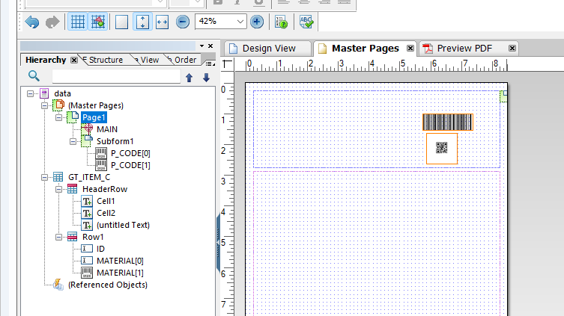

1. Right click the master page and select new master page set  
   